**Task 5 – Positive, Negative, or Zero**

**Algorithm**• Use prompt() to take an integer input from the user.

• Convert the input to a number using Number().

• Use if-else-if-else to check:

* If number > 0 → print "Positive"
* If number < 0 → print "Negative"
* Else → print "Zero"

• Show all results in both console and alert.

**Psudocode**

START

PROMPT user for number

CONVERT to number

IF number > 0

DISPLAY "Positive"

ELSE IF number < 0

DISPLAY "Negative"

ELSE

DISPLAY "Zero"

END

**Code(javascript)**

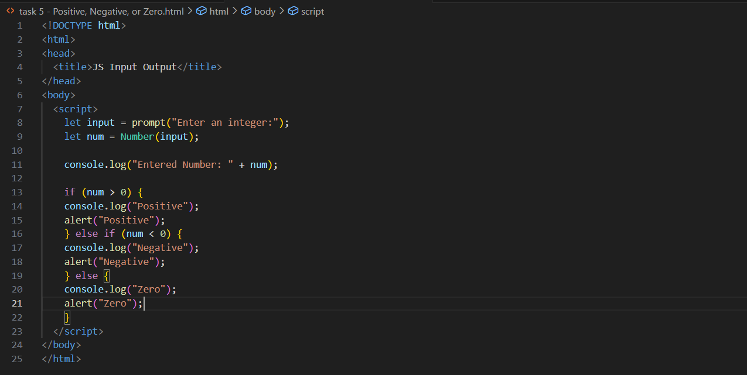

**Output (test case 1)**

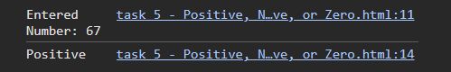  
**Output (test case 2)**

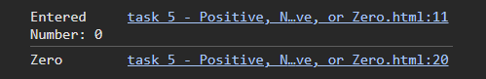  
  
**Output (test case 3)**

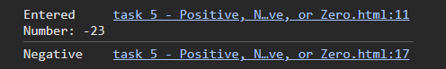

**Observations**

• The program correctly handles all integer values: positive, negative, or zero.

• Both the input and result are shown in the **console** and **alert** for full clarity.

• Uses Number() to ensure the input is treated numerically, avoiding string comparison issues.

• Clean example of **if-else-if-else** logic in JavaScript.